Lab Objective

Configuring Zone Delegation

**Lab Procedures**

**1.** On RWDC01, go to the DNS Manager console. Under Forward Lookup Zones, click and right-click Fabrikam.com and click New Delegation.

**2.** When the Welcome to the New Delegation Wizard starts, click Next.

**3.** In the Delegated domain text box, type **support** (as shown in Figure 8-4) and then click Next.

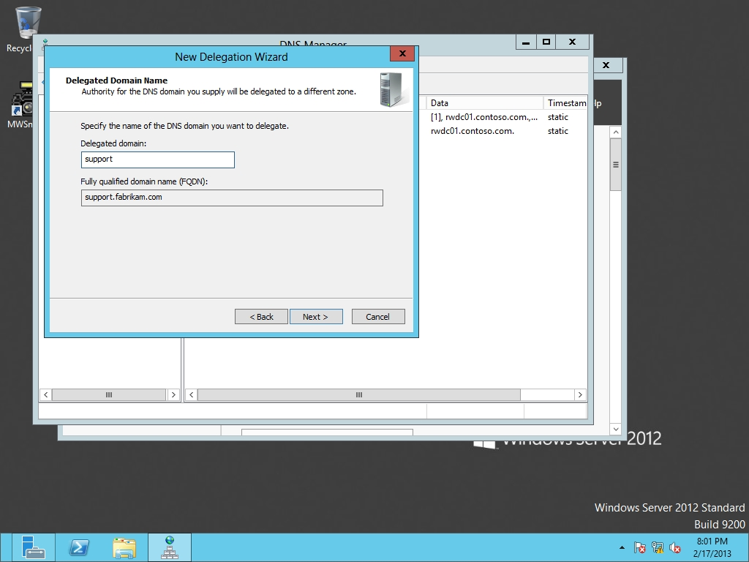

Figure 8-4

Delegating a domain

**4.** On the Name Servers page, click the Add button, type **Server01** in the *Server fully qualified domain name (FQDN)* text box, and click Resolve. Don’t worry about the red circle with the white X; the zone in Server01 still needs to be created. Click the OK button to close the New Name Server Record dialog box. Click Next.

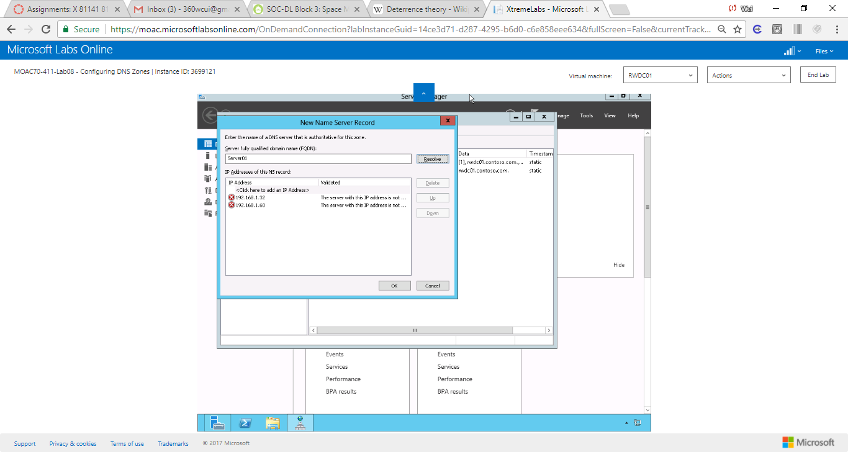

Figure On the Name Servers page, click the Add button, type Server01 in the Server fully qualified domain name (FQDN) text box, and click Resolve. Don’t worry about the red circle with the white X; the zone in Server01 still needs to be created.

**5.** When the wizard is complete, click the Finish button.

**6.** On Server01, go to the DNS Manager console. Right-click Forward Lookup Zones, and click New Zone.

**7.** When the New Zone Wizard starts, click Next.

**8.** On the Zone type, with the Primary zone already selected, click Next.

**9.** On the Zone Name page, type **support.fabrikam.com** in the Zone name text box and click Next.

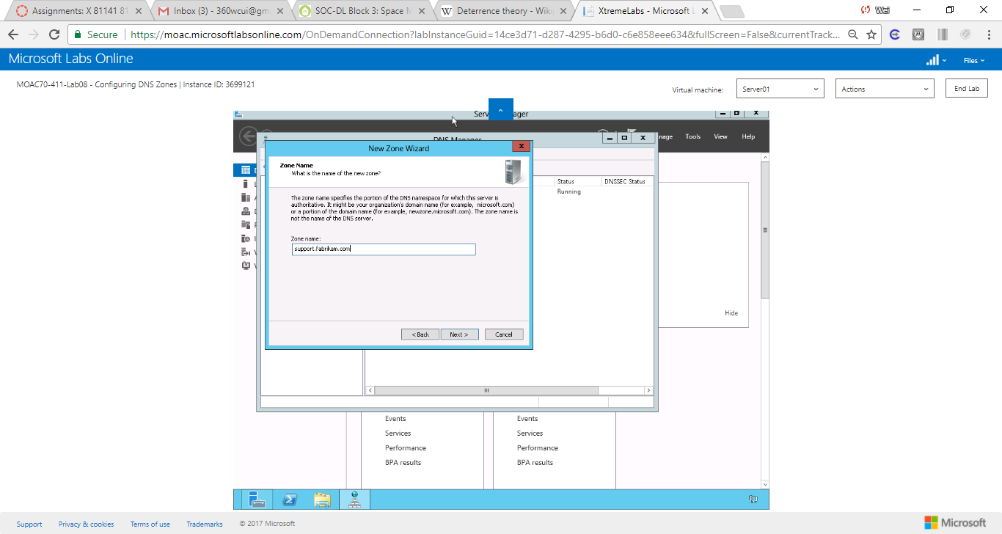

Figure On the Zone Name page, type support.fabrikam.com in the Zone name text box and click Next.

**10.** On the Zone File page, click Next.

**11.** On the Dynamic Update page, click Next.

**12.** When the wizard is complete, click Finish.

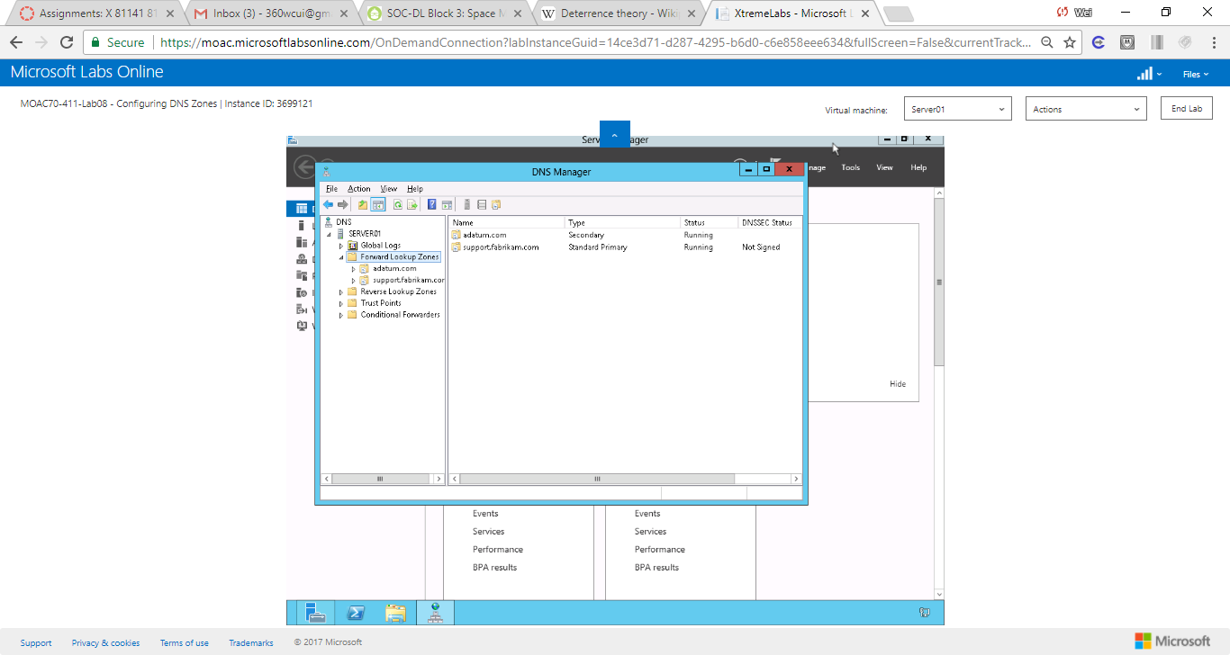

Figure Primary and Secondary Zones are created

**Lab Summary**

In this exercise, I delegated a subdomain called *support under fabrikam.com* on a different DNS server. Delegation allows the query resolved in the delegated DNS servers instead going all the way up to the root server. I would want to use zone delegation if the Contoso Corporation is geographically separated to reduce the process time. I would use conditional forwarding if the queries can be resolved locally to the network. For example, I can resolve the qureries outside my network such as those on the internet, A forwarder can improve the efficency of name resolution.